Check if described Monitoring thresholds are sufficient, valid and implemented

Open BlueCrest -Monitor

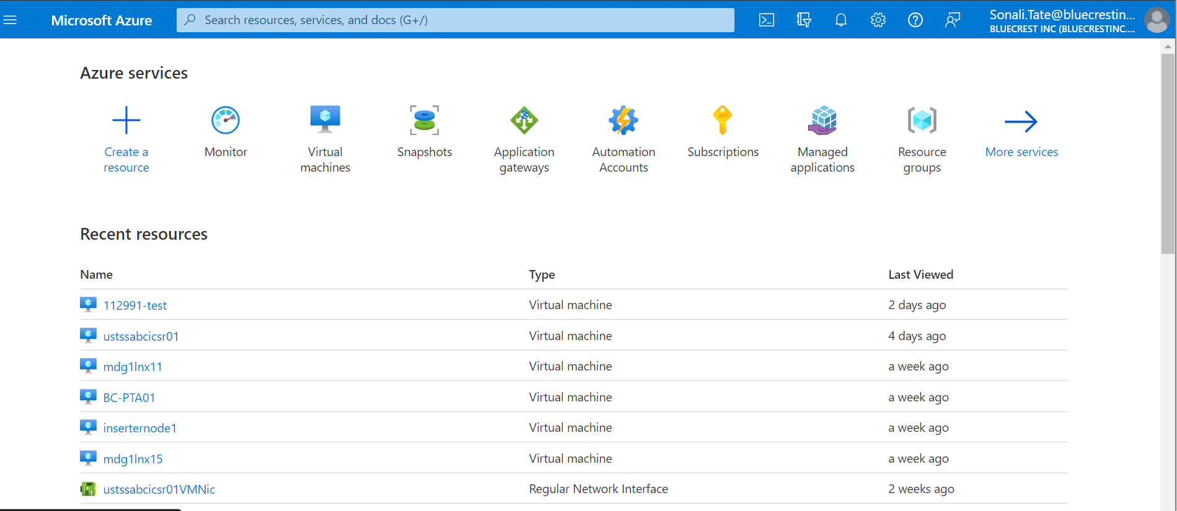

Overview

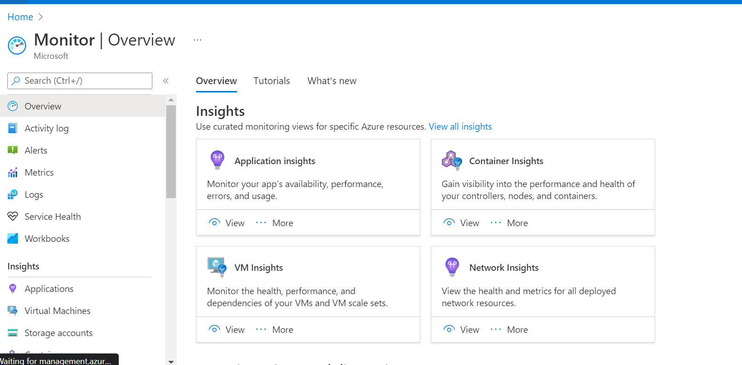

Alert

Myitor • 
Monitor - Overview 
Act" i ty I cg 
Logs 
Vim* I 
5tv.ge 
Demos 
Monitor your applications and infrastructure 
Get full Stack visibility. find and problems. optimize your and understand 
wstomer all in 
Monitor Visualize Metrics 
Metri% numö-ie• from 
help.ngyCJ the 
& of systems 
Query Analyze Logs 
Logs logs and 
mTitoring queriæ help 
with & 
Setup Alert Actions 
mtify you of 
take 
on 'mm metrics or 

One you click on Alert

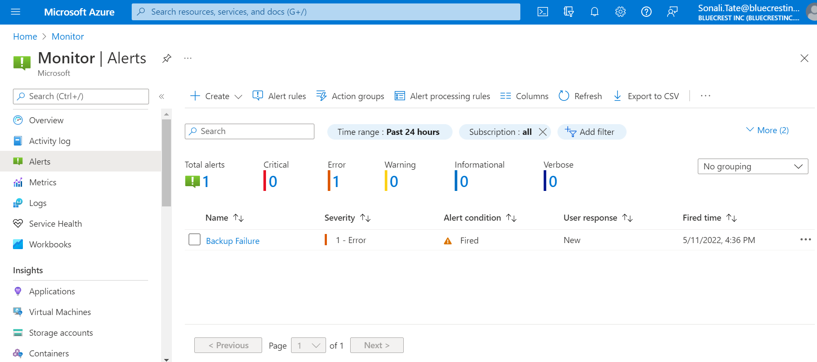

Check all the rules and see which rules need to be altered

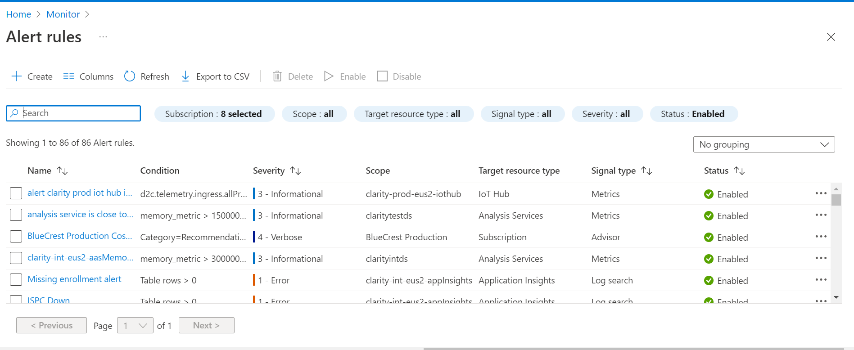

We can alert accordingly

